Brand culture
Jpbmanagement.com: LinkedIn

Brand equity capital de la marque
Opportunity, strength, treat, weakness SWOT
Opportunité et menaces : on ne les contrôle pas mais ça va impacter notre entreprise
Forces et faiblesses : on les contrôle

The new strategic brand management book

Quoi répondre si pas assez d’expériences : dire tous les autres trucs qu’on fait a coté

Brand value
Portfolio document where there are all our creations or our clients
Levers: leviers

Definition of brand:
A visual identity example: logo, symbol, a motto (devise)
Brand culture is the set of shared values, beliefs, behaviors and symbols that shape our brand is created, expressed and experienced by all its stakeholders both inside the organization (employees, leadership) and outside (customers, partners, communities)

It is the personality of a brand reflected across:
- What the brand stands for (vision, purpose, values)
- How it acts (customers interactions, employee behaviors, business decisions)
- How it communicates (tone, storytelling, symbolism)
- How it is perceived (reputation, associations, customers experience)

3 composantes for a brand to succeed:
- Vision
- Mission
- Values

Example: google and Harley Davidson
Brand culture of innovation and openness, expressed in its playful tone, internal work culture and product design
Brand culture of freedom and rebellion reinforced through its biker community and lifestyle positioning

In today’s competitive marketplace, brands have evolved far beyond simple logos and slogans
They represented value-creation engines that drive business succeed, influence consumers behavior and shape cultural meaning
Examines how brands function as powerful assets that generate value for manufacturers, distributors, retailers and consumers alike

Distribution channel:

Direct distribution from de producer to the consumer reduce the cost
Selling through retailers from producer to retailer to consumer
Selling through wholesalers or distributors from producer to wholesaler who sell to retailer who sell to consumer

Middlemen who perform some work in bringing the product closer

3 type de distribution:
- Selective (example: supermarket, or gallery Lafayette)
- Exclusive (premium prices example: Rolex)
- Intensive (disponible everywhere)

Wholesaler: grossiste
Retailer: detaillant

Why brand value matters?

Loyalty: fidélisation
CA: to make competitive advantage sustainable
If we have a good competitive advantage, you could improve your prices so have margins

What are the sources of brand value: manufacturers?

- Product quality & innovation: delivering superior performance or innovation builds trust and loyalty
- Brand equity & recognition: the strength of their brand name translates into customers preference and pricing power
- Heritage & storytelling: long) standing history or strong brand narrative create authenticity
- Marketing investment: brand-building campaigns endorsements, and sponsorship reinforce brand presence
- Intellectual property (IP): trademarks, patents, and design rights protection

Example: apple (manufacturers)
Create value through product design, software integration, and innovation (iPhone, mac)
Its powerful brand equity allows apple to command premium pricing and expand into services (apple music, iCloud)

Quality message: Gerblé

- La promesse : un aliment sain
- La preuve : un expert de la diététique + compo du produit
- Le bénéfice : consommateur mange sain et il le sait
- Le ton : le ton de l’expert, du conseiller

Travail: tesla manufacturer, distributors, retailers, consumers?

- Manufacturer
- Technological innovation (electric cars, autopilot, batteries)
- EV’s
- Product quality and performance
Result: Tesla can sell at higher prices and build customer loyalty.
- Distributors
- Easy access (shops, website)
- DTC direct to consumers
Result: Tesla maintains control over the customer experience from start to finish.
- Retailers (Tesla shops) consumers relationship management (CRM)
- The shopping or consumers experience reinforces the brand.
- Immersive test drives, premium experience
Result: Tesla sells a lifestyle, not just a car.
- Consumers
- They are the ones who bring the brand to life.
- Emotional attachment to the brand and its mission
Result: Customers become true brand ambassadors.
Manufacturer: builds brand equity through innovation (EV’s, autonomous, technology)
Distributors: tesla bypasses traditional distributors with direct-to-consumer channels, reinforcing exclusivity
Retailers: tesla’s retail stores (experience-focused) elevate the premium brand perception
Consumers: act as brand evangelists, sharing experiences online, strengthening the community and adding credibility
Advocacy defender les droits de la marque

Distributors, sources of brand value
- Association with strong brands: distributing well-known brands enhances their credibility
- Reliability and trust: delivering brands to market builds reputation with both retailers and manufacturers
- Exclusive distribution rights: being the only distributor of a brand generates bargaining power (5 forces de porter)
- Market coverage and reach: the ability to make a brand across countries adds value
- After-sales support: providing warranty or technical support strengthens brand reliability
Retailers, sources of brand value
- Shelf Space & Visibility: premium placement in-store or online boost brand
- Customer Experience: a retailer’s ambiance, service quality, and digital UX (users experience) elevate the perceived value of brands they carry
- Private Labels (MDD= marque de distributeur)) & Co-Branding: retailers create their own brand value
- Consumer Trust & Loyalty Programs: strong retailer brands amplify the brands they sell
- CA competitive advantage become sustainable
- Channel Control: exclusive launches or collaborations enhance desirability (rarefaction: scarcity)
R&D recherche et développement
Example : Sephora niche brands

SCP = segmentation – cibler – positionnement

Consumers (end-users, decision-makers)

- Perceived quality and status: the brand’s image drives personal identity expression
- Emotional connection: stories, values, and social causes resonate and build loyalty
- Word of mouth & social proof (=preuve social): positive reviews, social media posts and influencer advocacy amplify brand equity
- Community and belonging: some brands foster tribes
- Price sensitivity & loyalty: willingness to pay a premium or remain loyal underlines brand strength
Example: Nike identity just do it

Don’ts in brand names:
- Difficult spelling
- Hard to pronounce
Ex: napapijri;
Packaging play an important role in the consumer’s purchasing decision
A logo brand colors, font use

Integrated view
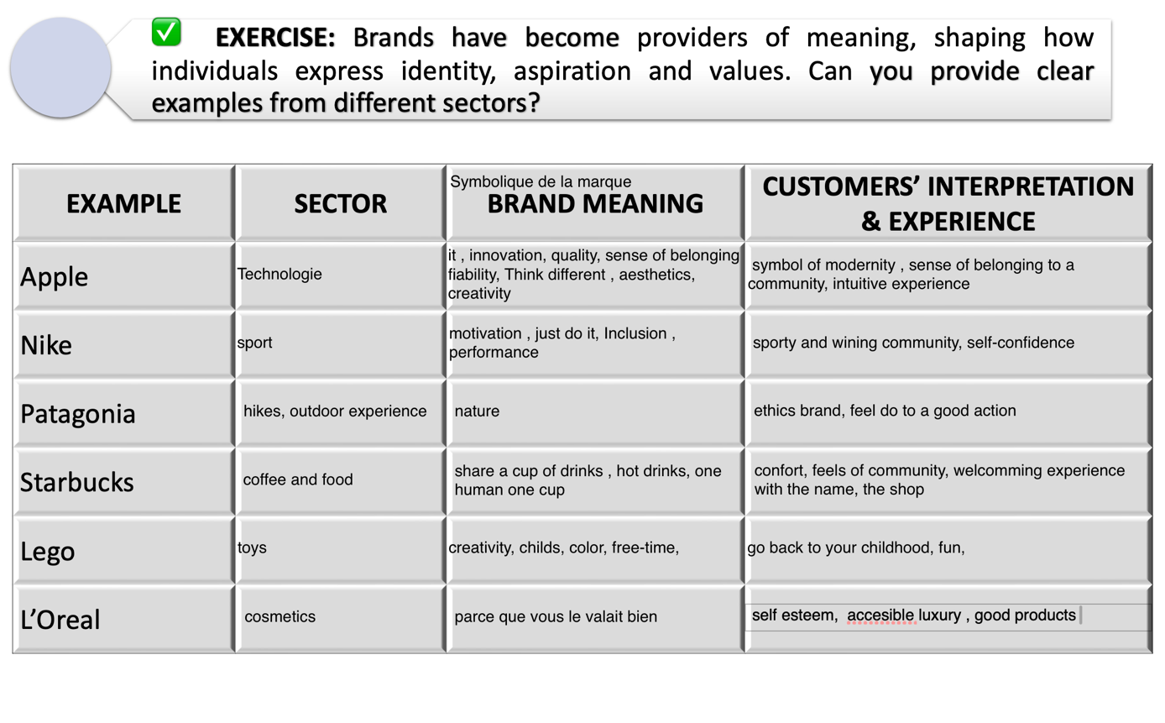

Part II

Brand culture vs corporate culture
Corporate culture: The internal environment of an organization
Brand culture: the externalized identity of a company

Focus:
- Corporate culture: employee experience, organizational structure, decision making, management style
- Brand culture: customer experience brand promise, marketing, storytelling and how shows up in the marketplace

Audience:
- Corporate culture: primarily internal stakeholders
- Brand culture: both internal and external stakeholders

Drivers:
- Corporate culture: driver by leadership values, HR policies, internal norms, office environment
- Brand culture: driven by brand purpose, consumer expectations, market positioning, cultural relevance

3 composante:
- vision where are we going?
- mission what are we capable of doing better than others?
- values comportment souhaité
A corporate strategy is a guide

Example : amazon mission

The brand life cycle :
- Introduction : build awareness and identity
- Growth : expand market share and loyalty
- Maturity : maintain differentiation
- Decline/renewal

BCG matrice application
- Market growth rate
- Relative market share

4 quadrants:
- Stars: high market growth, high market share
- Cash cows: low market growth, high market share
- Question marks: high market growth, low market share
- Dogs: low market growth and low market share

Define the scope: consider nespresso Europe focusing on :
- Its core product lines (original, vertuo, professional)
Market overview :
- Europe is a mature saturated coffee capsule market
- Growth is moderate with sustainability and premiumization
- Nespresso faces strong competition from brands like l’or , Lavazza and starbucks
Relative market share

Original: 40%; competitor 30% ;market 40/30= 1,33 cash cow
Vertuo: 35% ; competitor 30% ; market 35/30= 1,17 star
Professional: 20; competitor 25; market 20/25=0,8 question mark

Cash cow: actions focus on customer retention via loyalty programs (Nespresso club, sustainability rewards); emphasize recycling and refillable capsule initiatives to protect brand equity and meet EU sustainability regulations; optimize operational efficiency in supply chain and prioritize innovation only in flavors, packaging...

Star: actions expand system distribution across Europe, especially in emerging coffee capsule market; increase marketing and awareness around crema quality and capsule innovation; use personalization and digital platforms to lock in customers and to counteract l’or barista through exclusive partnership and limited edition blends
3. brand architecture
Architecture de marque: facon dont une organisation structure son portefeuille de marque
Ex : kering
Types of brand architecture :
- Monoholithic one identity ex: Porsche (master brand)
- Endorsed brands sub-brands (sous marque = pas péjoratif) ex : marriott ; dacia made by Renault
- Freestanding independent brand ex : Procter & Gamble
- Hybrid combination join venture ex: alphabet/google
4) brand portfolio management

